Contents

Simple crop model assimilating Remote Sensing data 1

Ground data needs 8

RS data assimilation 8

FAPAR products 8

Partitioning 8

Respiration 9

Phenology 9

The mixed pixel problem 9

Harvest Index 10

27 July 2014 12

GRAMI coupled with PROSAIL 12

Input data: 12

Basic equations: 12

Differences with GRAMI: 13

# Simple crop model assimilating Remote Sensing data

|  |  |
| --- | --- |
| **Objective and model output** | Pasture biomass and crop yield monitoring and forecasting (short term with weather forecast, long term with best/worst meteo data scenarios) |
| **Target area** | HoA, Sahel |
| **Target crops** | To be decided, grassland, Maize, Sorghum (and Wheat) |
| **RS data** | Classified in two classes:   1. RSveg: vegetation related (e.g. fAPAR, derived phonological parameters) 2. RSmet: meteo variable as derived by RS (Globrad from MSG, ET from MSG, rainfall estimates) |
| **Met Data** | ECMWF : T, Globrad |
| **Other** | Soil map (for RT and water balance) |

A simple crop/pasture growth model is coupled with a Canopy Reflectance (CR) model that simulates the spectral properties of the canopy for a given set of crop model parameters. RS data are assimilated into the crop model through parameter re-initialization (i.e. model parameters are adjusted to provide the best match between modeled and observed RS data).

The “crop model” is a semi-empirical crop model which core is based on Monteith LUE (Light Use Efficiency) model. Differently from other LUE based DM products (Vito DM, MOD17), RSveg-derived phenological observation are used to drive/describe crop development (e.g. partitioning) and RSveg data are not forced into the LUE model but are assimilated into it through parameter re-initialization. In principle this means that the model benefit from RSveg but does not depend on them. This ensures that:

* The process of growth is modeled also in absence of RS data (increased robustness against missing RS data and undesired RS data perturbations);
* Past RSveg observations are taken into account at each step avoiding unrealistic DM computation as provided by direct use of LUE (*);
* Possibility of forecasting using meteo data.

|  |
| --- |
| (*) consider two consecutive decades d1 and d2. According to the fAPAR at d1, LUE will estimate the DM at d1, regardless what will happen at d2. For example, if the fAPAR at d2 is equal to that at d1, LUE estimate of DM at d1 was probably wrong (maybe because of stress) but it will not be reanalyzed or changed. |

The crop model should be kept as simple as possible (see for example GRAMI proposed by Clement) and should be tuned with field data (this is why it is a semi-empirical model). The state variable is an effective LAI (**) which is converted into FAPAR using a radiative transfer model (RT) model (semi-discrete model of Gobron, PROSAILH, depending on fAPAR product used). fAPAR is a measurable quantity (in field) that can be estimated from satellite that summarizes two key information with regards to photosynthesis: LAI and Chl contents. The model is driven by phenology which again can be estimated from remote sensing. Clement suggests to use the reflectance instead of fAPAR (so that the algorithm is more flexible to assimilate different types of RS data). I personally agree but it may be more complex and longer to setup a system that can use different data sources, still if Clement is involved it may be feasible.

|  |
| --- |
| (**) In this case we have 3 different LAI:   1. The true one (the one that can be measured by harvesting); 2. The crop model LAI (which is somehow an abstraction related to the true LAI); 3. The effective RS LAI (again an abstraction related to the true LAI, more precisely it is the LAI value that, used in a given radiative transfer model, will enable to simulate the true – and measurable – optical properties of the target.   What is important here is that LAI n.2 and n.3 have to be matched. This can be done by empirical parameters placed in the crop model and adjusted with RS data. |

|  |  |
| --- | --- |
| **Fixed parameter** | **Role** |
| ***Growth model*** |  |
| lai0 | Initial LAI value (must be studied a bit, should not be too important since SOS is optimized) |
| εmax | maximum conversion factor |
| γ | autotrophic respiration factor. Now is the fraction retained after respiration, RE(t) = γ*GPP(t)  Re is modeled with T using q10 in MODIS PSN product |
| ***RT model*** |  |
| Rleaf | Fixed green |
| Tleaf | Fixed green |
| Rsoil | From TIP soil albedo before SOS |

|  |  |  |
| --- | --- | --- |
| **Parameter to be optimized** |  | **Prior** |
| ***Growth model*** |  |  |
| SOS | DOY at which the season starts with LAI = lai0 | Prior value of SOS is derived from the pheno analysis (avg SOS setting a very low threshold, e.g., 1%). SD can be also used |
| s | IF USED drives the response to water stress |  |
| αA | Partitioning into above ground |  |
| SLA | Specific Leaf Area |  |
| lifeSpanDD | leaf lifespan in degree days |  |
| ***RT model*** |  |  |
| Z | factor ZETA for computing an effective LAI to be used with a two-stream approach |  |
|  |  |  |
|  |  |  |

|  |
| --- |
| **Required data** |
| FAPAR |
| PAR [from GlobRad] |
| Tavg |
|  |
|  |

***Basic time evolution law on green LAI:***

LAI(t+1)=LAI(t) + ΔLAI(t)

ΔLAI(t) = LAIgrowth(t) -LAIsen(t)

Simulation starts at t=SOS with an initial condition of lai = lai0 (assumed fixed)

***Plant module (description of the growth and crop development):***

GPP(t) = εmax * εws* fAPAR(t) * PAR(t)

NPP(t) = GPP(t) – RE(t) = GPP(t) (1-γ) RE(t) = γ*GPP(t)

εws= 0.5 + 0.5 (AET/PET)* (This formulation or use the “s” concept of figure below)

* from Maselli et al. 2009a, AET is rainfall, PET is Jensen and Haise, 1963 (pag 663 of Maselli):

$$PET=\frac{Rs}{2450}\left(0.025 T_{avg}+0.08\right)$$

No eps coefficient is considered for temperature limitations but temperature has an indirect effect here

$${LAI}_{growth}\left(t\right)=SLA α_{A} NPP\left(t\right)= SLA α_{A} \left\{\left[ε_{max} ε_{ws}\left(t\right) FAPAR\left(t\right) PAR(t)\right]\left[1-γ\right]\right\}$$

LAIsen(t) = LAIgrowth(t0)

t0 = f(temperature, lifeSpanDD) ;where t0 is the day (days) where the cumulated T has exceeded the leaf lifespan in degree days

ΔLAI(t) = LAI_growth(t) - LAI_sen(t)

And, above ground biomass and yield:

$$AGB= α_{A} \sum_{SOS}^{EOS}{NPP\left(t\right)}$$

$$Yield= α_{G} \sum_{SOS}^{Max?}{NPP\left(t\right)}$$

**Simplification:**

SLA αA and γ are unknown and probably not constant during the season. Two approached are tested:

* Pooling them together in a constant k
* Pooling them together in a function kk(t) whit coefficients to be determined (liner? Quadratic?)

$${LAI}_{g}\left(t\right)=SLA α_{A} NPP\left(t\right)= kk(t) \left\{\left[ε_{max} ε_{ws}\left(t\right) FAPAR\left(t\right) PAR(t)\right]\right\}$$

What we know: SLA exp decay with time (Jarlan et al., 2012), partitioning the same (GRAMI), γ is a complex function that we assume constant. Overall an exponential may be attempted.

Doing either of the two, the NPP is not available anymore and Yield and ABG has to be defined on LAI

***Link with fAPAR from RS:***

fAPAR(t)=**CR_Model**(LAI(t)*ZETA, θRT(crop type, soil type))

OPPURE POTERI USARE COME STAT VARIABLE LA FAPAR E POI USARE LAMBERT BEER O UN MODELLO PER CALCOLARE IL LAI

POTREI SFRUTTARE IL SAIL 2 LAYER PER MODELLARE UNA FAPAR GREEN E UNA TOTALE (UTILIZZANDO IL LAI GREEN COME QUELLO ATTIVO E IL LAI NPV QUELLO ANDATO IN SENESCENZA) E POI CALCOLARE LE RIFLETTANZE E USARE QUELLE PER INVERTIRE (RIPARAMETRICCARE)

ALCUNI PARAMETRI POTREI OTTIMIZARLI SUGLI ULTIMI 5 ANNI (ASSUMENDO NO LAND COVE CHANGE)

**Assimilation**

Inversion in which initial conditions (SOS) and some model parameters are optimized.

**TIP Pinty (forward)**

The input LAI is an effective LAI (such as that measured by LAI2000).

**LAI process model Vs. LAI effective**

What’s the LAI process model? Maybe it’s a true LAI (one sided)

***Link RS:***

* Partitioning of GPP into organs is tabulated and driven by SOS, max(fAPAR), EOS (End of Season) [Clement suggests to keep partitioning dependent on degree days as in GRAMI];
* Parameter s (controlling sensitivity to stress factors is adjusted), lifeSpanDD are adjusted to match fAPAR dynamic [note that s may be indeed adjust the overall ε].

Where:

αA(t) is the partitioning of GPP into aboveground organs, αA(t)+ αB(t)+ αG(t) = 1 (B stays for Below – roots, G for Grains). The values are to be known a priori, but its time evolution is prescribed by the shape of the modeled FAPAR ??? (tipo dopo il max, quando è sceso del 20% ..??). Other approaches do exists (see GRAMI or Claverie 2012 RSE)

αG(t) as above. Maybe using a HI could be easier.

Leaf senescence is modeled as in GRAMI, so a dLAI is remove when its culmulated temperature exceed a specific lifespan in degree-days (lifeSpanDD). In Calverie et al 2012 RSE, they use a similar approach but with a senescence rate (Rs) applied to the temp sum from SOS (?).

εs is the stress reduction to conversion efficiency (water and T) two components εW and εT. In Kenya T may be relevant (up to 2700 m in Nyandarua district for example). It is independently estimated (from WSI for example, in a second time by RS PRI) but it is controlled by the parameter s (see figure below) which is, in turn, optimized using RS data. Felix and Clement point out that WSI (or similar approaches) are the result of a model with several assumption behind. It would be then preferred to use an observation (PRI in the future…). Felix suggests to have a look at the ET product of MSG.



Subject to:

* Partition is dictated by partitioning table based on phenology, so phenological dates eSOS (effective Start of Growing Season, which is the SOS derived by RS), eSL (effective Season Length) and grain filling start (use some relation with doy of max fAPAR) are to be estimated.
* εs is related to water stress. Can I use something similar to CSWB / WSI and compute ET as a function of fAPAR? Or adapt CSWB (planting dates from phenology)



|  |  |
| --- | --- |
| **MONITORING** | **FORECASTING** |
| Relevant model parameters are adjusted to match fAPAR | fAPAR is computed with retrieved coefficients, meteo forecast are used for the short term, best and worst meteo year are used for long term prediction |

**MONITORING MODE (from EOS to EOS+t)**

*Run over the past years:*

The phenology module is run over past years to detect business as usual eSOS, eSL and fractional occurrence of maximum in fAPAR (i.e. (doy_of_max_apar-eSOS)/eSL).

The model is run over the past years to derive model parameters best fitting fAPAR curves () and yield (αG or HI if simpler).

*During the current year:*

The model computation is activated when fAPAR exceed a given threshold found to correspond to eSOS in the previous years. Phenological model parameters eSL and doy_of_max_apar are taken from previous years as above.

Afterwards, the estimate of eSOS is updated (and the model is re-parameterized) every decade at each new fAPAR estimate delivery. At the same time, the coefficients s and β are optimized to model a state variable (LAI) which match the fAPAR. WSI is independently modeled at daily step.

In the model parameter optimization the weight of RS data should increase with the number of observations available because is the dynamic of fAPAR that matters.

Detection of disturbances:

Something like: At each step the algorithm optimize β globally (using all the time series) an locally, using last β estimate until t and estimates β1 at t+1. If β1 >> β, then a flag is risen. If this behavior is confirmed by subsequent observations, the value of the flag increases..

**FORECASTING SHORT TERM (from EOS+t to EOS+t+10 days)**

The model runs with last optimized parameters and ECMWF data

**FORECASTING LONG TERM (from EOS+t+10 to EOS+SL days)**

Use best and worst meteo years… ????

Example of model output

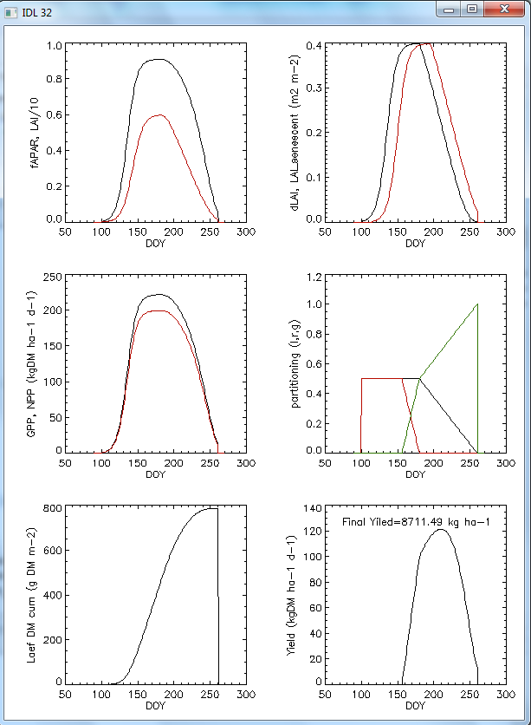

## Ground data needs

The application of the model needs data to tune [and validate] the model

|  |  |  |  |
| --- | --- | --- | --- |
| **Data** | **Importance (1-5)** | **Spatial samples** | **Available in Kenya** |
| Biomass at harvest | 5 | >=20 (as much as possible) | ? |
| Biomass sampled (green and total) over time (monthly) | 5 | >=4 in different regions |  |
| LAI or fAPAR sampled over time (monthly) | 3 | >=4 in different regions |  |
| Phenology (phenol-dates) | 5 | >=20 (as much as possible) |  |
| Yield | 5 | >=20 (as much as possible) | YES |
| SLA | 3 | Few selected |  |
| GPP from EC (Eddy Covariance) | 4 | - | NO |

Land cover: basic data is AFRICOVER which is an agricultural mask (agriculture / not agriculture) and not a crop specific mask). Then we have to check what is available at DRSRS. Alternatively there are the crop mask prepared for the paper of Oscar and Felix. In addition, ask Felix for a recent paper on Kenya classification he has seen.

Other data can be derived from literature and other sources: Leaf angle distribution, PROSPECT (leaf level RT) parameters; soil spectral signature, leaf life span (in deg days if the GRAMI approach is used)

## RS data assimilation

Assimilation is based on model parameters re-initialization.

The basic idea is to give more importance to the fAPAR trend than to the last information (maybe cloudy or whatever). The idea could be that when more fAPAR data are not in agreement with the model a flag is raised (big shock is happening)

## FAPAR products

Preferred algorithm: based on optimized indexes (Gobron et al.). Limitations: orography not considered, LUT for optimization has a max LAI of 5. There is also available an algorithm (always from Nadine) to derive FAPAR from MODIS 250m.

Other: FAPAR from Cyclopes (uses ANN to retrieve FAPAR from..? to be studied)

## Partitioning

Possibilities:

* Fixed HI;
* Partitioning tabulated (Wofost approach);
* Based on degree-days a sin GRAMI;
* Partitioning estimated by a model (Cropsyst) running in parallel with prior knowledge.

## Respiration

To be done..

*Mirco: Questione respirazione..che respirazione devi simulare, suolo, autotrofa o di ecosistema?  
Tutte si basano su T, diciamo che pero' se lo fai in ecosistemi semiaridi o aridi non troppo gestiti con irrigazioni dovresti tenere in considerazione anche le precipitazioni o l'acqua nel suolo altrimenti il rischio di sovrastima e' dietro l'angolo  
comunque esistono un bel po di modellini veramente semplici per Rsoil a partire da lloyd and taylor 1994 o da quelli che trovi nell'articolo di andrew allegato (Tab 1).  
Se usi questi, ed hai anche la GPP, secondo me uno spunto di lavoro sarebbe usare un Q10 intorno a 1.5 e lavorare modulando la respirazione basale con la GPP, almeno questo era quello che era uscito dall'articolo su science (trovi in allegato l'articolo ma guarda i supporting materials fig 5-6 in cui si vede la ral;azioen tra queste due variabili).   
Io poi ho fatto un modellino per la Reco che in generale non funzionava male e potrebbe essere un buon test..tieni presente che pero' non avevao siti africani ed e' quindi ottimizzato su eu, nord america e asia..*

## Phenology

Three possible approaches, two based on curve fitting:

1. Our approach (Busetto et al., 2010 GCB) based on the fitting of the entire curve [the approach is not general as it is.. it is suited for 1 growing season / year);
2. Verstaete approach on JRC-FAPAR products (Verstaete et al., 2008, Adv Space Res);
3. Anton Vrieling approach as suggested by Felix (data are available)

Focusing on approach n.2, it is divided in 3 steps:

1. Determine the number of growing season per year via autocorrelation
2. A sigmoid model (may be S or Z shaped depending on the slope) is fitted within a window containing a number of decades (i.e., 10). The window is displaced on all decades. Important parameters are b (the slope), and a (the amplitude of the curve).
3. Relevant dates are extracted using data from 1-2. Starting from the last analyzed growing season, with 1 it knows how many cycle it has to analyze. Then look for the FAPAR to exceed a given threshold (median of FAPAR). In that place it know that we are on the increasing side of the curve, approximately half way. It limits the following analysis to the period [-10,+20] decades: find the maximum of fitted a in the two cases: b positive (growing), b negative (senescence). SOS is the first decade of the first window, EOS is the last of the second window.

## The mixed pixel problem

Even if we decide to use MODIS 250 m the problem of the mixed pixel will be there. Even if probably in most part of the word it can only be ignored, Felix and Clement propose to deal with it focusing this work on the study area (Kenya) where a good land cover map should be available. A reliable land cover map at high resolution is the prerequisite for managing the mixed pixel problem. Clement proposes two very interesting things (Clement, the first one has be re-interpreted by me and my be different from your vision, if necessary correct):

1. Group the pixels into set of pixels (quite large, it may be a moving window for example). Then assume that all the crop in the set are the same and form an overdetermined system and find the parameters suiting all the observation at the same time. Mean and SD?? I have missed something
2. Regarding programming: do not develop a pixel by pixel program, try to work with matrix.

Anthesis is the period during which a [flower](http://en.wikipedia.org/wiki/Flower) is fully open and functional -> Antheis=Flowering

## Harvest Index

Simulating the fraction of the produced biomass that is allocated to grain constitutes, however, a greater challenge for these models. The methods used to simulate grain yield can be grouped in two general approaches: (1) simulating yield components (e.g. Villalobos et al., 1996), and (2) simulating the fraction of the total aboveground biomass allocated to the grain (harvest index, HI) (e.g. Williams et al., 1989; Sto¨ckle et al., 1994).

(Modeling crop yield using a modified harvest index-based approach: application in chickpea , A. Soltani, B. Torabi, H. Zarei)

**Seed yield accumulation is calculated as the product of biomass accumulation and harvest index (HI)**, and harvest index is assumed to increase linearly as a function of time after beginning seed growth with a constant rate (dHI/dt). The last method is based on the concept developed in soybean by Speath and Sinclair (1985) that HI linearly increases with time over much of the seed growth period. This response has also been observed in sorghum and maize (Muchow, 1988), peanut (Bennett et al., 1993), wheat (Moot et al., 1996), sunflower (Bange et al., 1998), chickpea (Soltani et al., 1999), field pea (Lecoeur and Sinclair, 2001), pigeonpea (Robertson et al., 2001a) and fababeen (Turpin et al., 2002). Furthermore, it has been shown that dHI/dt remains stable over a range of growth conditions such as variations in sowing date, irrigation treatments and N level (Moot et al., 1996; Bindi et al., 1999; Lecoeur and Sinclair, 2001). However, dHI/dt is not constant under vast conditions. In the conditions of severe water limitation during seed filling, HI ceases to increase (dHI/dt =0).

Phenology

Stages of development of **emergence** (50% of plants with some parts at soil surface), **flowering** (50% of plants with one flower at any node, R1), pod initiation (50% of plants with 0.5 cm pod at one of

the four upper nodes with unrolled leaf, R3), pod filling (50% of plants with peas beginning to develop,

R5) and **maturity** (50% of plants with pods yellowing, R7).

HI data were regressed against time (days after R1) with a three-piece segmented, non-linear

regression model (Eq. (1)) (Soltani et al., 2004). This model separates HI increase into distinct phases; zero

HI in phase 1; linear increase of HI in phase 2 and maximum HI in phase 3. The segmented model can be

expressed as:

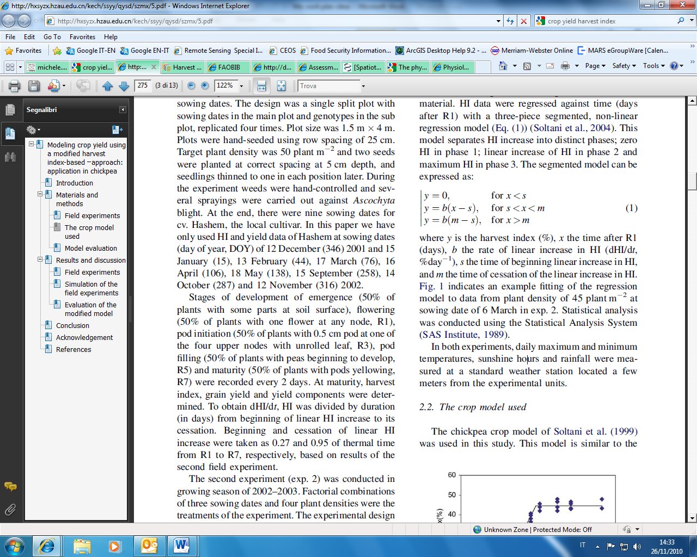

where y is the harvest index (%), x the time after R1 (days), b the rate of linear increase in HI (dHI/dt, %day_1), s the time of beginning linear increase in HI, and m the time of cessation of the linear increase in HI.

(A.R. Kemanian et al. / Field Crops Research 103 (2007) 208–216)

The simulation of HI has basically followed two approaches. One approach is to increase the HI from a given time after anthesis until physiological maturity or a maximum preset HI is reached (e.g. Williams et al., 1989). Hammer and Muchow (1994) and Hammer and Broad (2003) concluded that despite its simplicity, this method has limited applicability because it is difficult to assign a correct value to the HI increase rate and to the timing of the HI plateau onset, the latter usually occurring after two-thirds of the time between anthesis and physiological maturity (Hammer and Muchow, 1994). Another approach is to use functional relationships that estimate directly the final HI (Sto¨ckle et al., 1994). Sadras and Connor (1991) proposed a

functional relationship in which the HI is positively and asymptotically related to the fraction of water transpired after anthesis ( fT) (Passioura, 1997; Richards and Townley-Smith, 1987). To develop their model, it was assumed that the contribution of preanthesis assimilates to yield decreases linearly as fT increases (Richards and Townley-Smith, 1987), biomass was corrected by the energetic cost of producing carbohydrate-, oil-, or protein-rich tissue, and transpiration was normalized by the vapor pressure deficit (Bierhuizen and 1Slatyer, 1965).

We propose that HI is related to fG, the latter defined as the ratio between aboveground biomass produced post-anthesis and that produced from emergence to maturity. Similar to Sadras and Connor (1991), HI is computed at physiological maturity without providing the time evolution of grain growth.

The simplest relationship is to assume that HI is a linear function of fG with slope s or: dHI/dfG = s. Integration yields:

HI= HIo + s*fG (1)

where the intercept HIo represents HI when there is no change in biomass from anthesis to maturity ( fG = 0).

# 27 July 2014

Use as a base the GRAMI model

## GRAMI coupled with PROSAIL

Main IDL routine: simForwMod.pro

### Input data:

* Tair, RFE and Globrad from ECMWF
* MODIS reflectances at 8 day time step

### Basic equations:

$$∆GDD=Max\left[T_{a}-T_{b},0\right]$$

$$FAPAR=PROSAIL\left(LAI\right)$$

$$∆GPP= ε_{max} ε_{s} FAPAR PAR$$

*εs is currently set to 1

$∆LAI=∆GPP P_{1} SLA- {∆LAI}_{sen}$

*Partitioning:*

*Original GRAMI model:*

$$P_{1}=Max\left[1-ae^{b GDD},0\right]$$

This equation does not explicitly take neither the period in which P1>0, nor the curvature. Both parameters are somehow implicitly described by the combination of the two parameters a and b. In addition: the initial P1 value depends on a and b; the effect of b changes in function of a.

The new hyperbolic function is

$$P_{1}=Max\left[if GDD ≤a: 1- \frac{GDD}{GDD+e^{b}\left(a-GDD\right)} if GDD >a:0, 0\right]$$

Now b is a curvature parameter (-inf;+inf) with cases: negative (convex function), 0 (straight line), positive (concave function)

*Leaf senescence:*

The ΔLAI emerged at time t with GDD(t) is removed after J growing degree days.

$$J\left(t\right)=c+d GDD\left(t\right)$$

### Differences with GRAMI:

* GDD is compute from emergence
* GDD is used only to compute leaf lifespan and partitioning, not to determine phenology
* Partitioning is computed using a different equation explicitly taking into account the length of period in which assimilates are partitioned into leaves and the curvature
* DOY0 is determined in the inversion of the model against RS observation
* PROSAIL is used to compute FAPAR (see details in d:\Users\meronmi\Documents\IDL\simmod\Coupled Model\PROSAIL\DOCS\ MM modifications to prosail.docx

Lifespan:

* As a function of stress besides degree days

HI:

* To be invented

Mirco:

* Towers on semi-arid: 3 in Sapin managed by Mirco, 2 of Baldocchi in California, + those of Carboafrica (we found 2), Mongolian plateau (maybe 3 towers)

Towers:

* Tonzi Ranch (California, molto spesso in stress idrico, Baldocchi)
* Spain (Las Majadas del Tietar Tower Site), 2004-2012

Usare dati meteo ECMWF e meteo stazione

Usare anche GPP per inversione (su tanti siti e lo valido solo in un paio)

Mirco to do:

* Respiration
* Eps_s on water stress

Possibilità per water stress:

* Use swir (see Fensholt presentation)
* Use pri (impossible as we only have TOA radiance)
* Simple water balance (WSI approach)
* Use T (evaporative fraction of Nutini/Olioso)
* Memory concept of Knorr et al., 2010 (J of Geophys. Research)*
* VPD (una metodo di stima in Jolly 2005)
* Using a deviation from PRI Vs NDVI?
* Using a single bucket model (Choler et 2010)

* Idea: water stress acting mainly on two processes: GPP and accelerate senescence. In general, GPP will be reduced if there is insufficient water for transpiration. At which level this will happen will depend on the various drought adaptation mechanisms of the target ecosystem.

To avoid a full water balance modelling the following simplification is proposed:

Water availability at given time t* and GDD* is given by the weighted average of the precipitation experienced so far. The integration period GDD_IP has to be determined. Past precipitation events are weighted with an exponential decay so that the closest precipitations are more relevant. Precipitations are also capped to take into account that excess precipitation is not retained in the soil. The capping threshold CAP has to be determined or fixed. GDD is used instead of time on the X-axis do that the x distance in between days increases proportionally to the temperature experienced. The integration period GDD_IP has to be determined.

$$EWP\left({GDD}^{*}\right)= \frac{\int_{-∞}^{0}{min\left[P\left(GDD+x\right), CAP\right] e^{x/{GDD_IP}} dx}}{\int_{-∞}^{0}{ e^{x/{GDD_IP}} dx}}$$

$$ε_{s}= \frac{EWP}{OWP}$$

OWP is an optimal weighted average precipitation to be determined in inversion against eddy data.



Note in this way that there is no link between biomass and water needs (water limits eps_s independently by the amount of LAI present).

At the code level, this limitation on eps is activated by the flag **eps_wlimOnOff = 1.**

And, in leaf senescence:

Originally as $J\left(t\right)=c+d GDD\left(t\right)$

Here we assume the existence of a potential life span of c GDD that is the lifespan of a leaf in optimal conditions (no water stress).

The leaf emerged at time t_e is removed at time t_s when

$$\int_{t_e}^{t_s}{∆GDD\left(t\right) \frac{1}{ε_{s}\left(t\right)}dt}=c$$

This means that the daily increase of GDD is over-weighted if the target was in water stress

ATTENZIONE SE eps va a 0

DA FARE

* Simulare la senescence in funzione delle precipitazioni più che I DGG..

Problemi riscontrati:

* JD0 viene assegnato con punti decimali, io ho fatto FLOOR(JD0) prima di chiamre simmod ma non è il massimo, Dom: valutare simmod a FLOOR(JD0) e CEILING (JD0) e interpolare

Provo ad interpolare f tra i due interi più vicini, funziona meglio non si incanta, interpolazione può essere codificata meglio

* Upperenvelope fatto come in Chen (non utilizzando i pesi come in pheno)
* Schema di pesatura min max per ndvi per dare più peso alla stagione nell’inversione